CENTOS (2)

VMCreation done

OS installation done

GIT

**Installation of GIT**

=====================

check whether java is installed or not

yum install curl curl-devel

yum groupinstall "Development Tools"

yum install gettext-devel openssl-devel perl-CPAN perl-devel zlib-devel

go to github page and download latest git source code

https://github.com/git/git/releases

wget link

mv v2.12.0-rc0.tar.gz to /opt/software/.

rename the v2.12.0-rc0.tar.gz to git-2.12.tar.gz

untar it using the command

tar -xzf git-2.12.tar.gz

cd git-*

make configure

./configure --prefix=/usr/local

make install

make

git --version

come to roots home dir ------

cd

git config --global user.name "your Name"

git config --global user.mail "you@example.com"

git config --list

mkdir project any where

cd project

git init

ls –la

cat > abcd.txt

this is git

git add abcd.txt

git commit –m “first commit” abcd.txt

git remote add origin <https://github.com/nithin85/2017.git>

git remote –v

git push –u origin1 master

my repository add <https://github.com/iJacob10/2017.git>

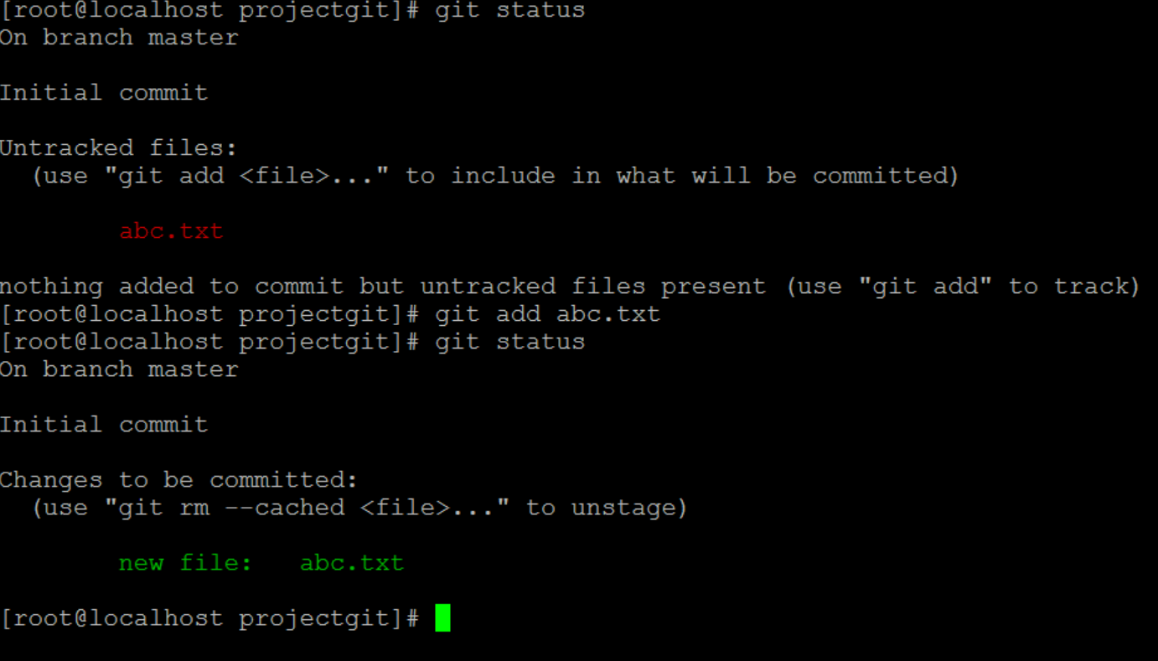

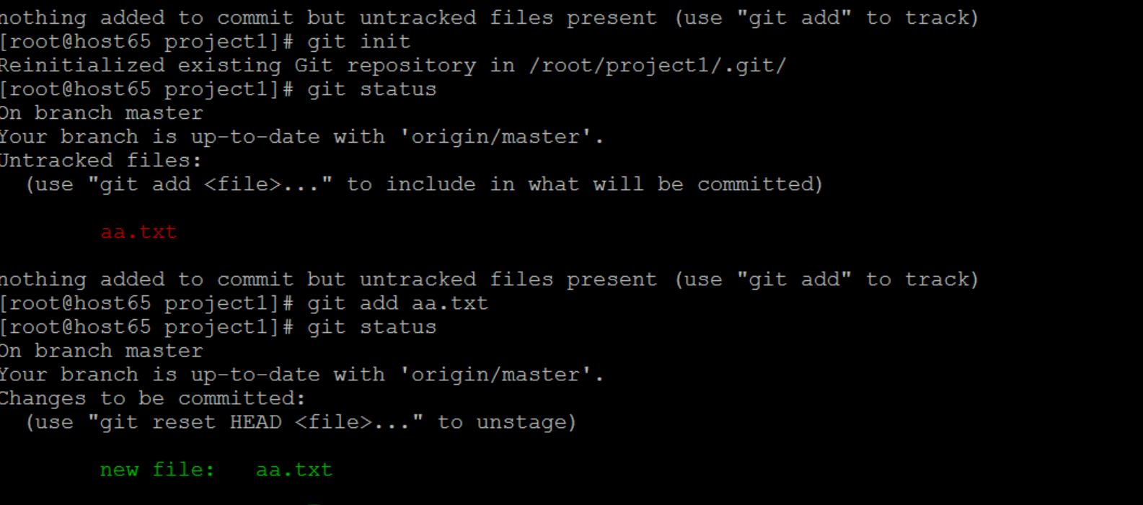

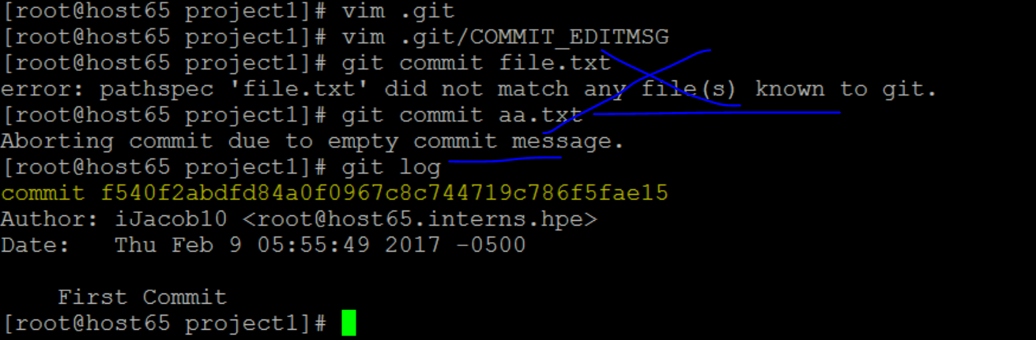

ID verified by Check sum algo

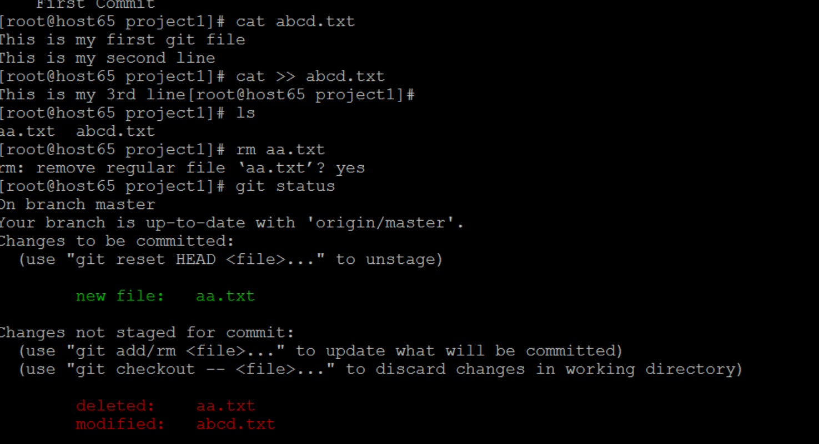

HEAD -> points to the latest commit of the file

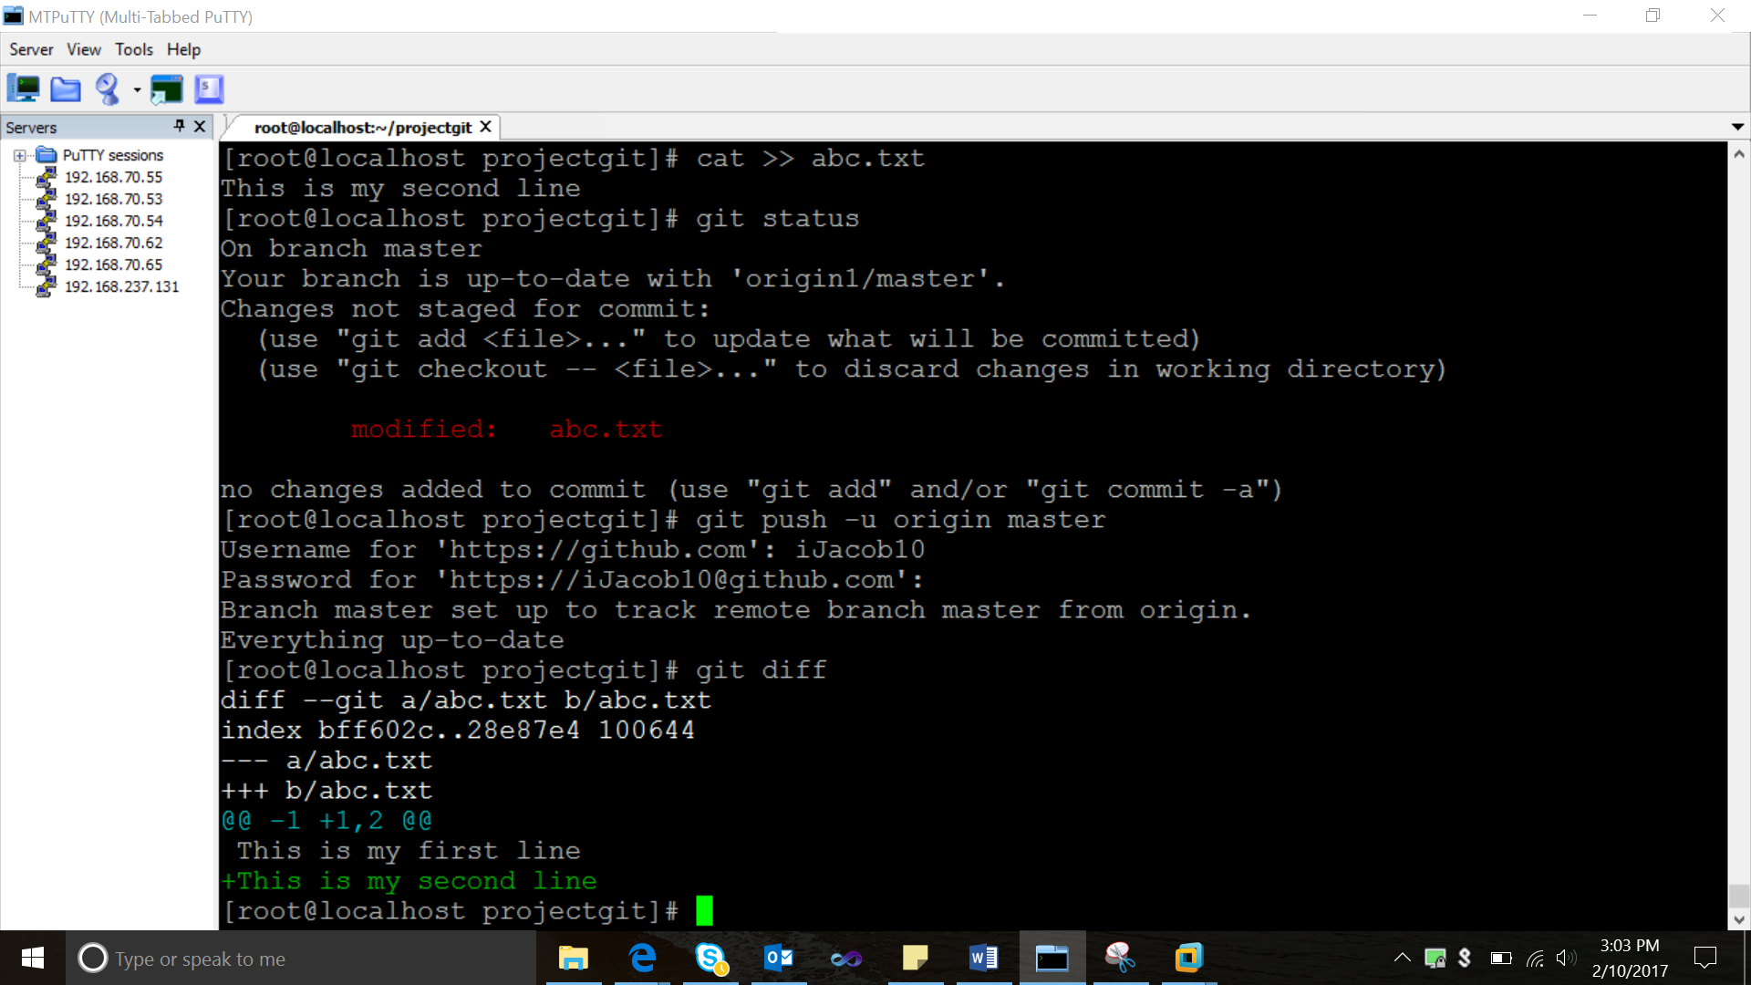

+this is second line ->unstaged(1st add and commit =indexed->>>>>STAGED)

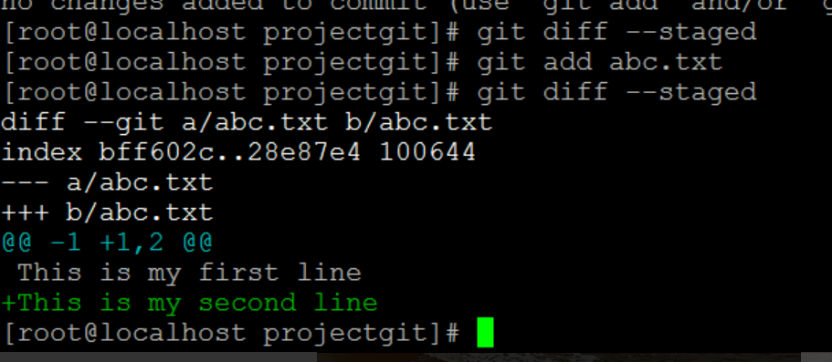

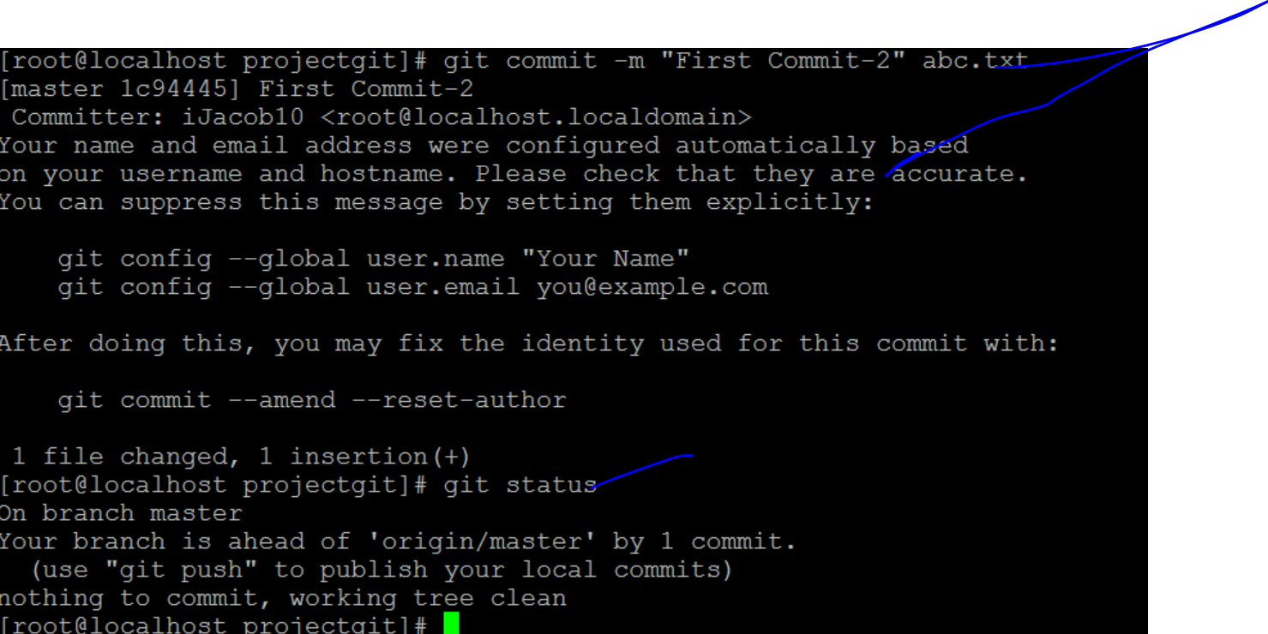

Origin ->>global repo…need to push it…to global repository

(your branch is ahead of origin/master by 1 commit)->>>updates local repo…n not global repository

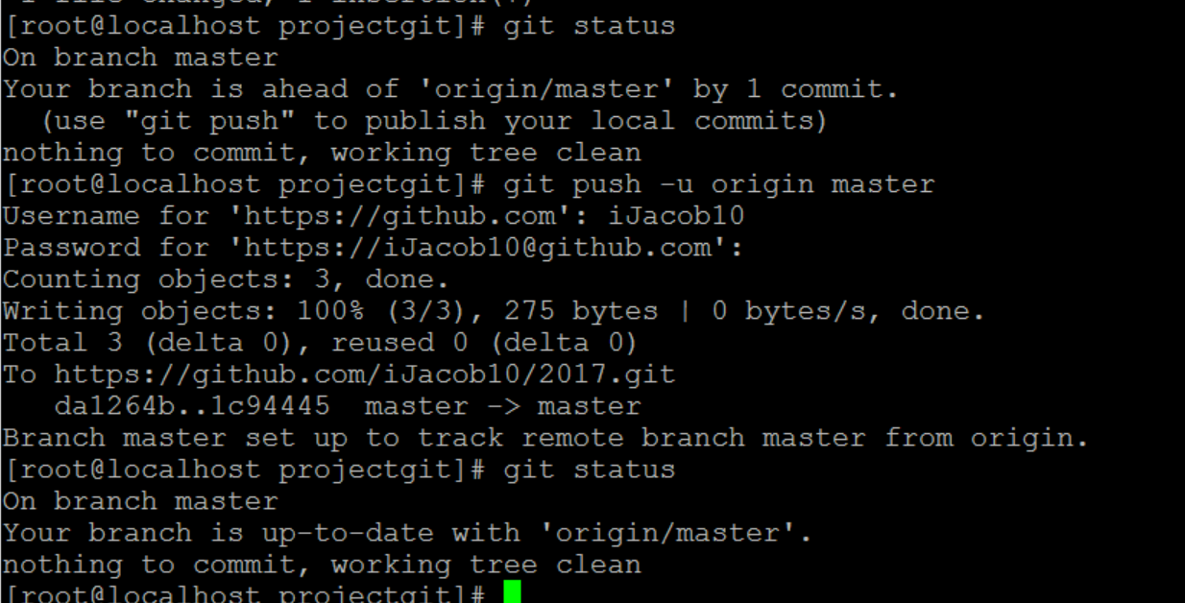

Now pushed to global repository

[root@localhost projectgit]# git log

commit 42f77a8a1246916a66879b77a368fc491a46bff2

Author: iJacob10 <root@localhost.localdomain>

Date: Fri Feb 10 15:21:17 2017 +0530

Commit-3

commit 1c94445fcfcf7e6ec4f71ae6f817977f37b02bb1

Author: iJacob10 <root@localhost.localdomain>

Date: Fri Feb 10 15:13:31 2017 +0530

First Commit-2

commit da1264b6735ab09d9b720072a7ef3023eea8f420

Author: iJacob10 <root@localhost.localdomain>

Date: Fri Feb 10 13:53:30 2017 +0530

First Commit

[root@localhost projectgit]# ^C

[root@localhost projectgit]# git diff 42f77a8a1 1c94445fcf

diff --git a/abc.txt b/abc.txt

index 4c83184..28e87e4 100644

--- a/abc.txt

+++ b/abc.txt

@@ -1,3 +1,2 @@

This is my first line

This is my second line

-this is third line

[root@localhost projectgit]# git diff 1c94445fcf 42f77a8a12

diff --git a/abc.txt b/abc.txt

index 28e87e4..4c83184 100644

--- a/abc.txt

+++ b/abc.txt

@@ -1,2 +1,3 @@

This is my first line

This is my second line

+this is third line

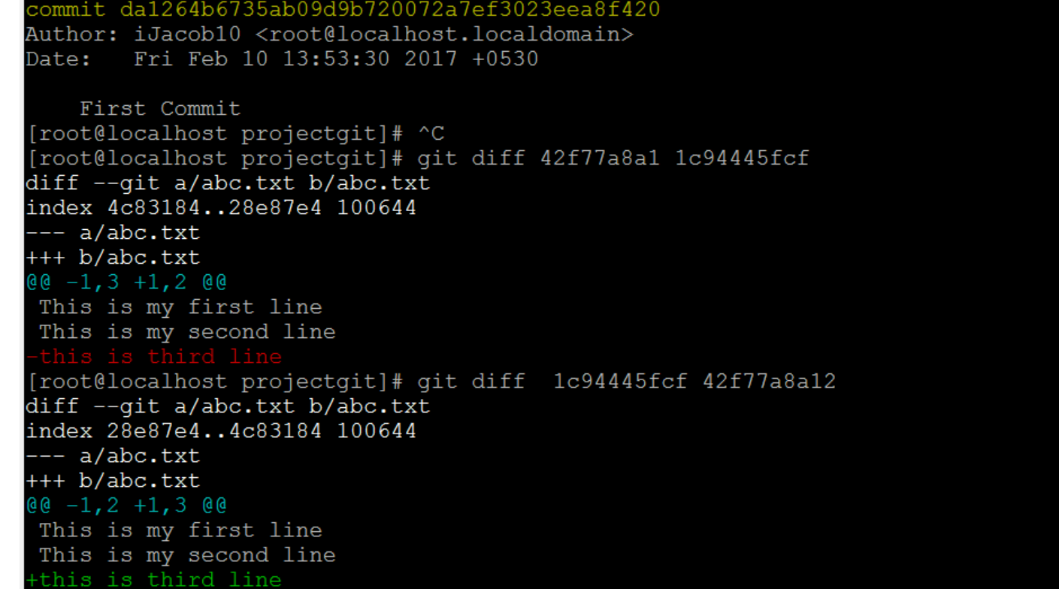

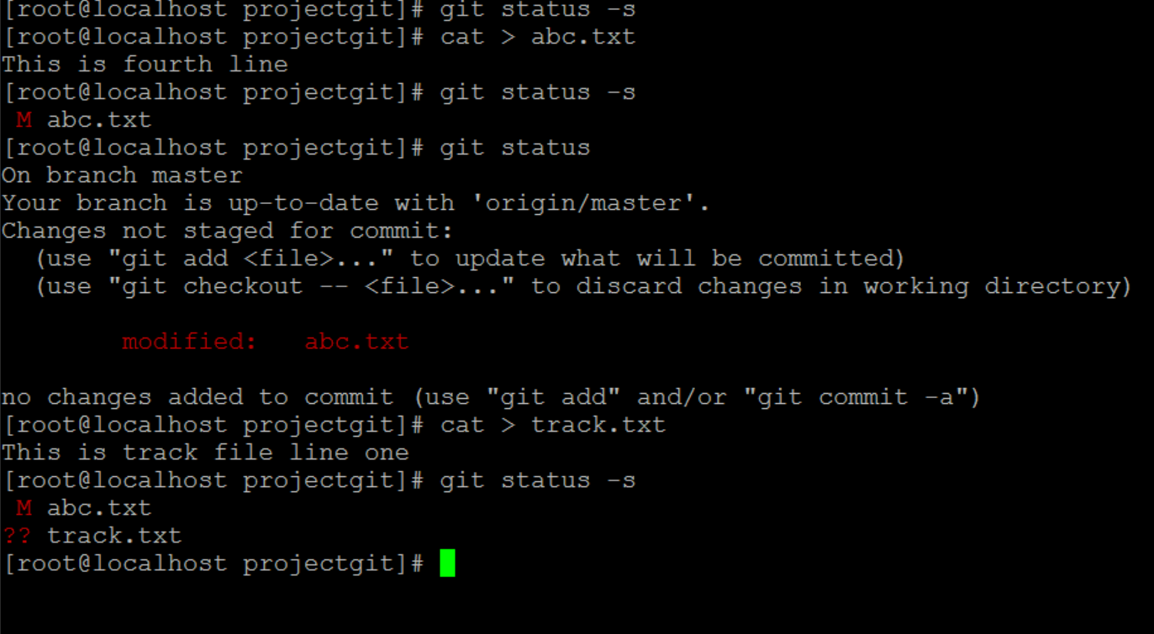

Tracked file track.txt

Staged track.txt

